Install Docker + Kubernetes on CentOS 7.8

Install a single node of Kubernetes using minikube on CentOS 7.8. Ensure your system has a min of 2 CPUs required for Kubernetes.

User: foundry

Password: lumada

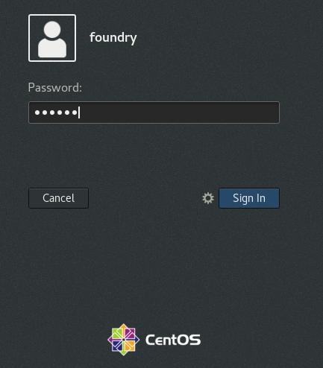

But first, let’s update the package database:

Right mouse and select

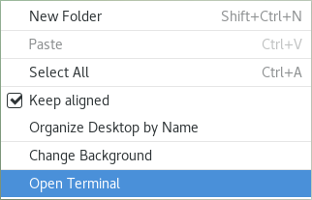

$ sudo yum check-update

$ sudo yum -y update

Pre-requisites

Hostnames

Before you start, it is advised to check what your current hostname is. Type the following command in the console to find out:

$ hostnamectl

$ sudo nano /etc/hosts

Add to the 127.0.0.1 line

bookinf.local and test.bookinfo.local

set hostname as localhost

$ hostnamectl set-hostname localhost

Later you will need to map the external loadbalancer IP address to locahost

Check the SELinux Status

To view the current SELinux status and the SELinux policy that is being used on your system, use the sestatus command:

Switch to Root user

$ sudo -i

# sestatus

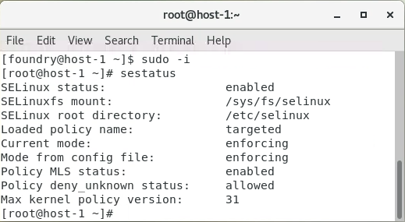

# setenforce 0

Open the /etc/selinux/config file and set the SELINUX mod to disabled:

$ sudo nano /etc/selinux/config

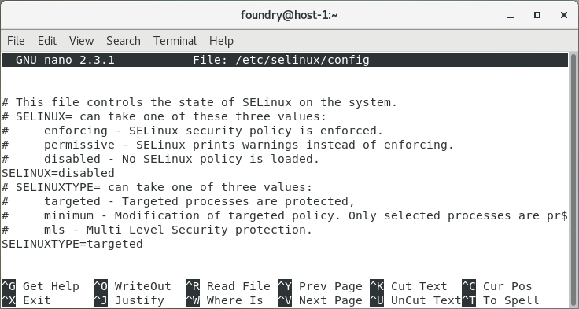

Disable SWAP

$ sudo swapoff -a

Reboot Server

$ reboot

Install Git

You will need to install Git to access the GitHub repository

$ sudo yum -y install git

Create a directory for course-materials

$ sudo mkdir /opt/course-materials/Istio

Now that we have git installed, we need to configure it so that it links to a repository.

# git config

Add name and email address for commits

root@host [~]# git config --global user.name "User Name"

root@host [~]# git config --global user.email "yourname@domain.com"

View the configuration information

root@host [~]# git config --list

exit

Install Visual Code

To install the stable 64-bit VS Code from a yum repository:

$ yum check-update

$ sudo yum -y update

$ sudo rpm --import https://packages.microsoft.com/keys/microsoft.asc

$ sudo sh -c 'echo -e "[code]\nname=Visual Studio Code\nbaseurl=https://packages.microsoft.com/yumrepos/vscode\nenabled=1\ngpgcheck=1\ngpgkey=https://packages.microsoft.com/keys/microsoft.asc" > /etc/yum.repos.d/vscode.repo'

$ sudo yum install code

$ code

Install the following extensions:

Docker 1.7.0

Kubernetes 1.2.1

vscode istio snippets 0.1.0

Install Docker

The purpose of the install script is for a convenience for quickly installing the latest Docker-CE releases on the supported Linux distros. It is not recommended for deployment to production systems.

$ curl -fsSL https://get.docker.com -o get-docker.sh

$ sudo sh get-docker.sh

After installation has completed, start the Docker daemon:

$ sudo systemctl start docker

Verify that it’s running:

$ sudo systemctl status docker

The output should be like the following, showing that the service is active and running:

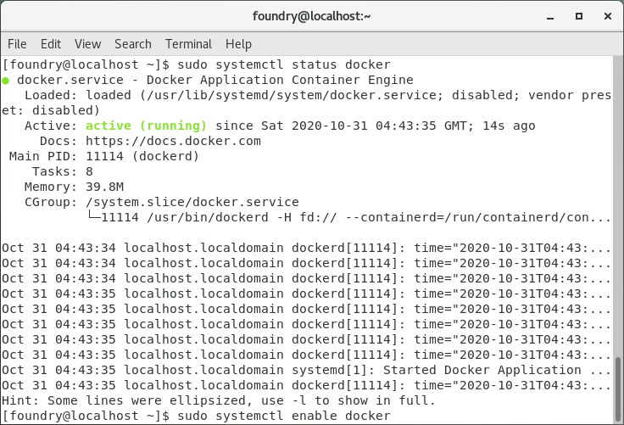

Lastly, make sure it starts at every server reboot:

$ sudo systemctl enable docker

Executing Docker Command Without Sudo (Optional)

By default, running the docker command requires root privileges — that is, you must prefix the command with sudo. It can also be run by a user in the docker group, which is automatically created during the installation of Docker. If you attempt to run the docker command without prefixing it with sudo or without being in the docker group, you’ll get an output like this:

Output

docker: Cannot connect to the Docker daemon. Is the docker daemon running on this host?.

See 'docker run --help'.

If you want to avoid typing sudo whenever you run the docker command, add your username to the docker group:

$ sudo usermod -aG docker $(whoami)

You will need to log out of the Droplet and back in as the same user to enable this change.

If you need to add a user to the docker group that you’re not logged in as, declare that username explicitly using:

$ sudo usermod -aG docker username

The rest of this article assumes you are running the docker command as a user in the docker user group. If you choose not to, please prepend the commands with sudo.

Start & Stop Docker Services

$ sudo systemctl start docker.service ## <-- Start docker ##

$ sudo systemctl stop docker.service ## <-- Stop docker ##

$ sudo systemctl restart docker.service ## <-- Restart docker ##

$ sudo systemctl status docker.service ## <-- Get status of docker ##

Using the Docker Command

With Docker installed and working, now’s the time to become familiar with the command line utility. Using docker consists of passing it a chain of options and subcommands followed by arguments. The syntax takes this form:

docker [option] [command] [arguments]

To view all available subcommands, type:

$ docker

Output

Output

attach Attach to a running container

build Build an image from a Dockerfile

commit Create a new image from a container's changes

cp Copy files/folders between a container and the local filesystem

create Create a new container

diff Inspect changes on a container's filesystem

events Get real time events from the server

exec Run a command in a running container

export Export a container's filesystem as a tar archive

history Show the history of an image

images List images

import Import the contents from a tarball to create a filesystem image

info Display system-wide information

inspect Return low-level information on a container or image

kill Kill a running container

load Load an image from a tar archive or STDIN

login Log in to a Docker registry

logout Log out from a Docker registry

logs Fetch the logs of a container

network Manage Docker networks

pause Pause all processes within a container

port List port mappings or a specific mapping for the CONTAINER

ps List containers

pull Pull an image or a repository from a registry

push Push an image or a repository to a registry

rename Rename a container

restart Restart a container

rm Remove one or more containers

rmi Remove one or more images

run Run a command in a new container

save Save one or more images to a tar archive

search Search the Docker Hub for images

start Start one or more stopped containers

stats Display a live stream of container(s) resource usage statistics

stop Stop a running container

tag Tag an image into a repository

top Display the running processes of a container

unpause Unpause all processes within a container

update Update configuration of one or more containers

version Show the Docker version information

volume Manage Docker volumes

wait Block until a container stops, then print its exit code

Install Kubernetes

* Install kubectl
* Install kind
* Install minikube

Install kubectl on Linux

Download the latest release with the command:

$ curl -LO "https://storage.googleapis.com/kubernetes-release/release/$(curl -s https://storage.googleapis.com/kubernetes-release/release/stable.txt)/bin/linux/amd64/kubectl"

Make the kubectl binary executable.

$ chmod +x ./kubectl

Move the binary in to your PATH.

$ sudo mv ./kubectl /usr/local/bin/kubectl

Test to ensure the version you installed is up-to-date:

$ kubectl version --client

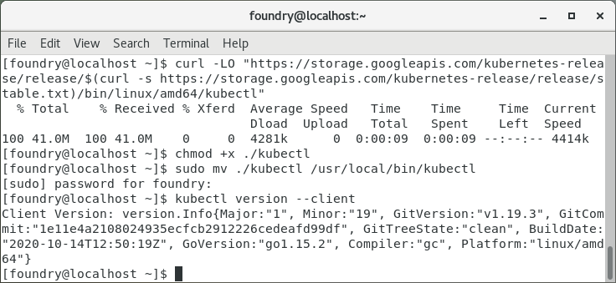

Install Kind

$ sudo mkdir /opt/kind

$ curl -Lo ./kind https://kind.sigs.k8s.io/dl/v0.9.0/kind-linux-amd64

$ chmod +x ./kind

$ sudo mv ./kind /opt/kind

Install Kubernetes - Minikube

$ sudo install minikube-linux-amd64 /usr/local/bin/minikube

From a terminal with administrator access (but not logged in as root), run:

$ minikube start --driver=docker

If minikube fails to start, see the drivers page for help setting up a compatible container or virtual-machine manager.

To make docker the default driver:

$ minikube config set driver docker

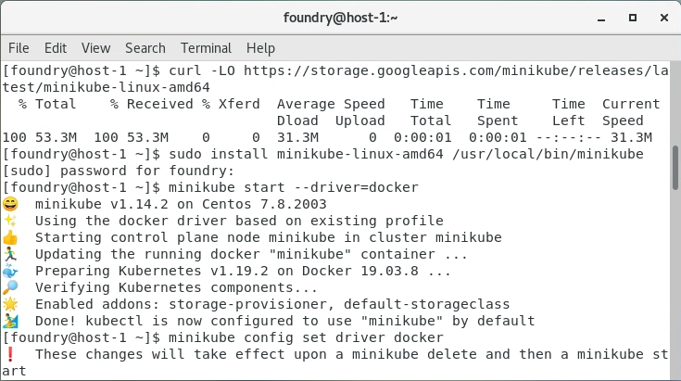

$ minikube stop

$ minikube delete

Set a loadbalancer

$ minikube tunnel

Install Istio

Go to the [Istio release page](https://github.com/istio/istio/releases/) to download the installation file for your OS, or download and extract the latest release automatically (Linux or macOS):

$ curl -L https://istio.io/downloadIstio | sh -

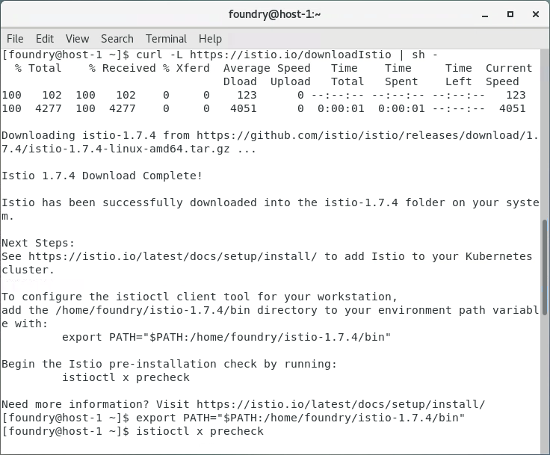

Add the istioctl client to your path

$ sudo nano ~/.bashrc

$ export PATH=”$PATH:/home/foundry/Istio-1.7.4/bin”

Run the check

$ istioctl x precheck

$ istioctl profile list

